Determine the optimal value of K in K-Means Clustering

There is a popular method known as **elbow method** which is used to determine the optimal value of K to perform the K-Means Clustering Algorithm. The basic idea behind this method is that it plots the various values of cost with changing k. As the value of K increases, there will be fewer elements in the cluster. So average distortion will decrease. The lesser number of elements means closer to the centroid. So, the point where this distortion declines the most is the **elbow point**.

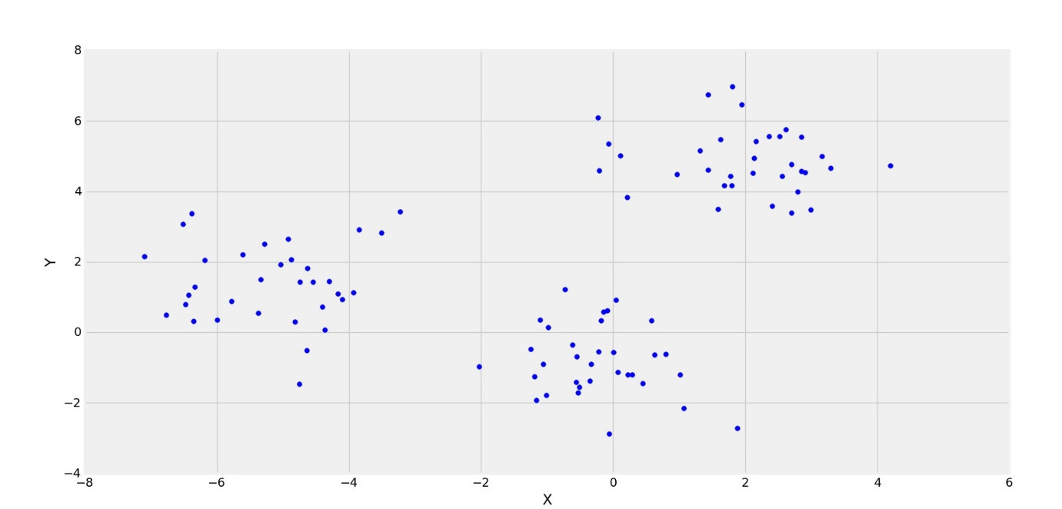

In the above figure, its clearly observed that the distribution of points are forming 3 clusters. Now, let’s see the plot for the squared error(Cost) for different values of K.

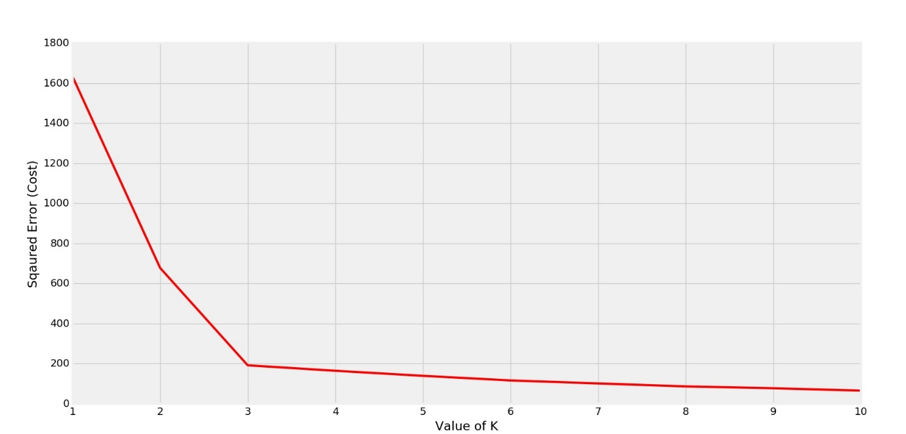

Clearly the elbow is forming at K=3. So the optimal value will be 3 for performing K-Means.